WICKHAM MARKET PARISH COUNCIL | 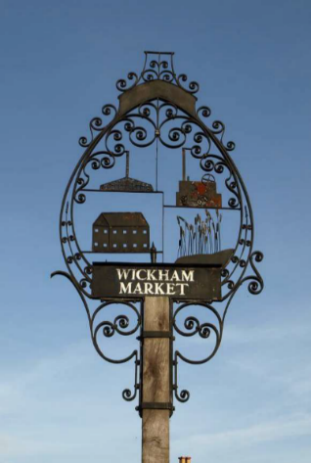
Chairman: Cllr Ivor French
Parish Clerk: Joanne Peters, Neutral Farm House, Mill Lane, Butley. IP12 3PA
Tel: 07723 634169 E-Mail: wickhammarketparishclerk@gmail.com
Website: www.wickhammarket.onesuffolk.net

NOTICE IS HEREBY GIVEN THAT THE NEXT MEETING OF THE NEIGHBOURHOOD PLAN COMMITTEE WILL BE HELD VIRTUALLY VIA ZOOM ON TUESDAY 13th OCTOBER 2020 at 19:00hrs

Members of the public are welcome to attend. Please contact Joanne Peters, Parish Clerk by 12:00 noon on the day of the meeting for login details

AGENDA

- Zoom Meeting Protocol Guidance
- Open Public Forum (Maximum 5 minutes)
- Chairman’s opening remarks
- To receive apologies for absence
- To receive declarations of pecuniary and non-pecuniary interests
- To approve the draft minutes of the Neighbourhood Plan Committee meeting held on Tuesday 15th September 2020
- Matters outstanding since last meeting and to update Action List
- ESC Local Plan approval.
- Planning Application - DC/20/3264/FUL – 134 dwellings in Pettistree, but within the Wickham Market settlement boundary.
- Request by Landowner to develop Jubilee and Low Farm Fields.
- Old School Farm update
- NP progress and next steps
  - To amendments to the Neighbourhood Plan
  - Consultation Statement (update)
  - Habitats Regulation Assessment (update)
- Matters of report and items for the next meeting
- Date of next meetings: 3 Nov 20, 8th Dec 20

Signed: Joanne Peters, Parish Clerk Dated 5.10.2020

