WICKHAM MARKET PARISH COUNCIL | 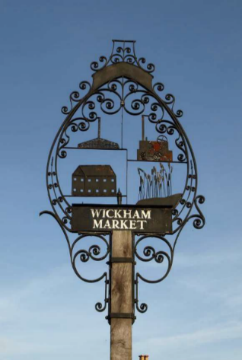
Chairman: Cllr Ivor French
Parish Clerk: Joanne Peters, Neutral Farm House, Mill Lane, Butley. IP12 3PA
Tel: 07723 634169 E-Mail: wickhammarketparishclerk@gmail.com
Website: www.wickhammarket.onesuffolk.net

NOTICE IS HEREBY GIVEN THAT A VIRTUAL MEETING OF THE NEIGHBOURHOOD PLAN COMMITTEE WILL BE HELD ON

TUESDAY 8TH DECEMBER 2020 AT 7:00PM VIA ZOOM

Members of the public are welcome to attend. Please contact Joanne Peters, Parish Clerk by 12:00 noon on the day of the meeting for login details

AGENDA

- Zoom Meeting Protocol Guidance
- Open Public Forum (Maximum 5 minutes)
- Chairman’s opening remarks
- To receive apologies for absence
- To receive declarations of pecuniary and non-pecuniary interests
- To approve the draft minutes of the Neighbourhood Plan Committee meeting held on Tuesday 3rd November 2020
- Matters outstanding since the last meeting and to update the Action List
- Planning Application - DC/20/3264/FUL – 134 dwellings in Pettistree, but within the Wickham Market settlement boundary – Update on informal meeting held with Ben Woolnough, ESC (to be given at meeting)
- Update on meeting held with Andrea McMillan, ESC, Chris Bowden, Navigus Planning and Sunila Osbourne, CAS (to be given at meeting)
- NP progress and next steps
  - To consider amendments to the Neighbourhood Plan
  - Consultation Statement (update from the Chairman)
  - Habitats Regulation Assessment (update from the Chairman)
- Budget update (to be given at meeting)
- Review of Schedule
- Matters of report and items for the next meeting
- Date of next meetings: 12 Jan & 9 Feb 2021

Signed: Joanne Peters, Parish Clerk Dated 1st December 2020

