WICKHAM MARKET PARISH COUNCIL | 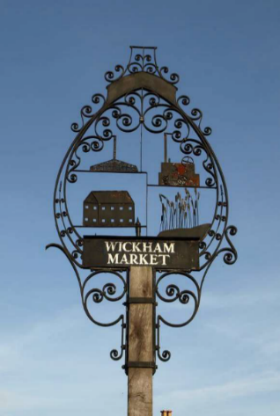
Chairman: Cllr Ivor French
Parish Clerk: Joanne Peters, Neutral Farm House, Mill Lane, Butley. IP12 3PA
Tel: 07723 634169 E-Mail: wickhammarketparishclerk@gmail.com
Website: www.wickhammarket.onesuffolk.net

NOTICE IS HEREBY GIVEN THE NEXT VIRTUAL MEETING OF THE NEIGHBOURHOOD PLAN COMMITTEE WILL BE HELD ON

TUESDAY 12TH JANUARY 2021 AT 7:00PM VIA ZOOM

Members of the public are welcome to attend. Please contact Joanne Peters, Parish Clerk by 12:00 noon on the day of the meeting for login details

AGENDA

- Zoom Meeting Protocol Guidance
- Open Public Forum (Maximum 5 minutes)
- Chairman’s opening remarks
- To receive apologies for absence
- To receive declarations of pecuniary and non-pecuniary interests
- To approve the draft minutes of the Neighbourhood Plan Committee meeting held on Tuesday 8th December 2020
- Matters outstanding since the last meeting and to update the Action List
- To consider response received from the Old School Farm site landowner
- Suffolk County Council: Help Shape Guidance for New Housing Developments in Suffolk – To consider correspondence received
- NP progress and next steps
  - To consider comments received from ESC Neighbourhood Planning Policy Officer and amendments required to the Neighbourhood Plan
  - Consultation Statement (update)
  - Habitats Regulation Assessment (update)
- Review of Schedule
- Budget Update (to be given at meeting)
- Matters of report and items for the next meeting
- Date of next meetings: 9 Feb & 9 Mar 2021

Signed: Joanne Peters, Parish Clerk Dated: 5th January 2021

