WICKHAM MARKET PARISH COUNCIL

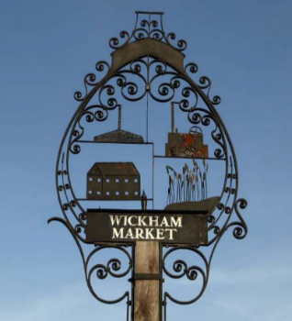
Chairman: Cllr Ivor French
Parish Clerk: Jo Peters, Neutral Farm House, Mill Lane, Butley, Suffolk. IP12 3PA
Tel: 07723 634169, E-Mail: wickhammarketparishclerk@gmail.com
www.onesuffolkwickhammarket.net

NOTICE IS HEREBY GIVEN THAT THE NEXT VIRTUAL MEETING OF THE ENVIRONMENT & LEISURE COMMITTEE will be held on Monday 15th February 2021 at 7:00pm via Zoom

Members of the public are welcome to attend. Please contact Joanne Peters,
Parish Clerk for the meeting login details

AGENDA

- Open Public Session

- To receive apologies for absence

- To receive declarations of interest

- To approve the draft minutes of the E & L Committee meeting held on Monday 14th December 2020

- Actions & Matters Arising from meeting held on Monday 14th December 2020:-
  - - Trees on Church Pightle – Cllr Westover to report on
  - - Village Sign – Cllr Horsnell to report on next stages of work
  - - King Edward Ave – Footpath - Update
  - - Simons Cross Drainage - Update

- Village Hall/Playing Field
6.1 - VHCIO, Bowls & Football club leases – To receive an update from Cllr Chenery
  - - To consider correspondence received from the VH CIO including flooding in the
car park
  - – Dog Fouling – To consider actions required

- Other matters
  - – Quiet Lanes update
  - – Siting of defibrillator in the telephone kiosk at Spring Lane - Update
  - – To consider matters relating to the Skate Park – Repairs required – To receive an
update from Cllr Horsnell
  - - Parish Environment Group planting – Update to be given by Cllr Westover

- To consider any matters relating to the allotments

- To consider any matters relating to the cemetery

- Matters of report and items for the next meeting

- Date of the next meeting – Monday 19th April 2021

Signed: Joanne Peters, Clerk to the Council Dated: 9th January 2021

