WICKHAM MARKET PARISH COUNCIL

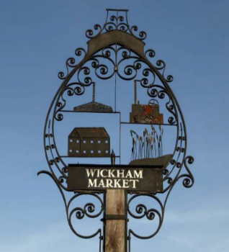
Chairman: Cllr Ivor French
Parish Clerk: Jo Peters, Neutral Farm House, Mill Lane, Butley, Suffolk. IP12 3PA
Tel: 07723 634169, E-Mail: wickhammarketparishclerk@gmail.com
www.onesuffolkwickhammarket.net

NOTICE IS HEREBY GIVEN THAT THE NEXT MEETING OF THE ENVIRONMENT & LEISURE COMMITTEE WILL BE HELD VIRTUALLY
on Monday 19th October 2020 at 7:00pm via Zoom

Members of the public are welcome to attend. Please contact Joanne Peters,
Parish Clerk for the meeting login details

AGENDA

- Open Public Session

- To receive apologies for absence

- To receive declarations of interest

- To approve the draft minutes of the E & L Committee meeting held on Monday 17th August 2020

- Actions from meeting held on Monday 17th August 2020 update:-
  - - Trees on Church Pightle – Cllr Westover to report on
  - - Village Sign update – Cllr Horsnell to report on
  - - Simons Cross Flooding/Drainage issues
  - - War Memorial and Garden - Erection of a flagpole update
  - – Siting of hand sanitiser stations update

- Village Hall/Playing Field
6.1 - VHCIO, Bowls & Football club leases – To receive an update from Cllr Chenery

- Other matters
  - – Quiet Lanes update
  - – Weekly Wednesday & Saturday Markets
  - – Men’s Shed Project – To consider siting this on the Glebe Allotment site
  - – Handyman – Works Schedule
  - – Parish Tree Planting

- To consider any matters relating to the allotments

- To consider any matters relating to the cemetery
9.1 – Update on Oak Tree
9.2 – Rabbit Gassing costs & way forward
9.3 – Cemetery Regulations update
9.4 – Any other matters relating to the cemetery

- Matters of report and items for the next meeting – To agree 2021/2022 Budget

- Date of the next meeting – Monday 14th December 2020

Signed: Joanne Peters, Clerk to the Council Dated: 12th October 2020

