WICKHAM MARKET PARISH COUNCIL

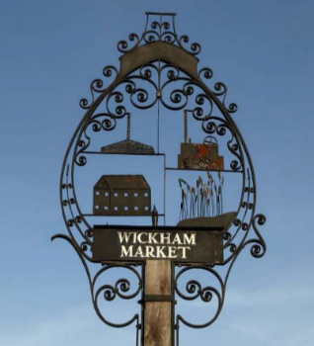
Chairman: Cllr Ivor French
Parish Clerk: Jo Peters, Neutral Farm House, Mill Lane, Butley, Suffolk. IP12 3PA
Tel: 07723 634169, E-Mail: wickhammarketparishclerk@gmail.com
www.onesuffolkwickhammarket.net

NOTICE IS HEREBY GIVEN THAT THE NEXT MEETING OF THE ENVIRONMENT & LEISURE COMMITTEE WILL BE HELD VIRTUALLY
on Monday 14th December 2020 at 7:00pm via Zoom

Members of the public are welcome to attend. Please contact Joanne Peters,
Parish Clerk for the meeting login details

AGENDA

- Open Public Session

- To receive apologies for absence

- To receive declarations of interest

- To approve the draft minutes of the E & L Committee meeting held on Monday 19th October 2020

- Actions & Matters Arising from meeting held on Monday 19th October 2020 update:-
  - - Trees on Church Pightle – Cllr Westover to report on
  - - Village Sign – To consider the next stage of work – Cllr Horsnell to report on
  - - Simons Cross Flooding/Drainage issues – To receive an update

- Village Hall/Playing Field
6.1 - VHCIO, Bowls & Football club leases – To receive an update from Cllr Chenery
6.2 – Flooding at Village Hall

- Other matters
  - – Quiet Lanes update
  - – Siting of a defibrillator in the telephone kiosk at Spring Lane – To agree costs
(Community Heartbeat Foundation in attendance)
  - – To consider matters relating to the play area and correspondence received from SC Norse
  - - King Edward Ave - Footpath
  - – To approve the dates of the 2021 Committee meetings
  - - To consider the E & L Committee draft 2021/22 budget

- To consider any matters relating to the allotments

- To consider any matters relating to the cemetery – Cllr Westover to provide update at meeting.

- Matters of report and items for the next meeting

- Date of the next meeting – Monday 15th February 2021

Signed: Joanne Peters, Clerk to the Council Dated: 7th December 2020

