WICKHAM MARKET PARISH COUNCIL
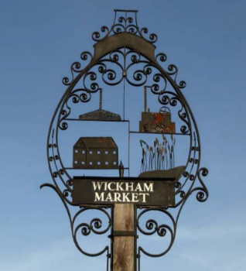
Chairman: Cllr Ivor French
Parish Clerk: Jo Peters, Neutral Farm House, Mill Lane, Butley, Suffolk. IP12 3PA
Tel: 01394 459400, E-Mail: wickhammarketparishclerk@gmail.com
www.onesuffolkwickhammarket.net

NOTICE IS HEREBY GIVEN THAT A VIRTUAL MEETING OF THE
PLANNING COMMITTEE will be held on Monday 1st February 2021
at 7:00pm via Zoom

AGENDA

MEMBERS OF THE PUBLIC AND PRESS ARE WELCOME TO ATTEND
(Please contact the Parish Clerk by 6:00pm on the day of the meeting for login details)
This meeting will be recorded by the Parish Clerk

- To receive apologies for absence

- To receive Councillors Declarations of Interest

- Open Public Session:–
Residents are invited to give their views and question the Parish Council on issues on this agenda or raise issues for future consideration at the discretion of the Chairman. Members of the public, whilst welcome to attend, may not take part in the meeting itself.

- To approve the minutes of the Planning Committee meeting held on Monday 21st December 2020

- To consider the following Planning Applications:-
Planning Ref: DC/21/0039/FUL
Proposal: Provision of external doors in place of window, new window to bedroom 1
en-suite, also erection of garden shed and attached greenhouse.
Address: 1 Featherbroom Gardens, Wickham Market

Planning Ref: DC/21/0201/FUL
Proposal: Proposed single storey rear extension to existing single storey dwelling
Address: 14 Churchill Crescent, Wickham Market

- To consider any other applications received at the discretion of the Chairman

Signed: Joanne Peters, Clerk to the Council Dated: 25th January 2021

